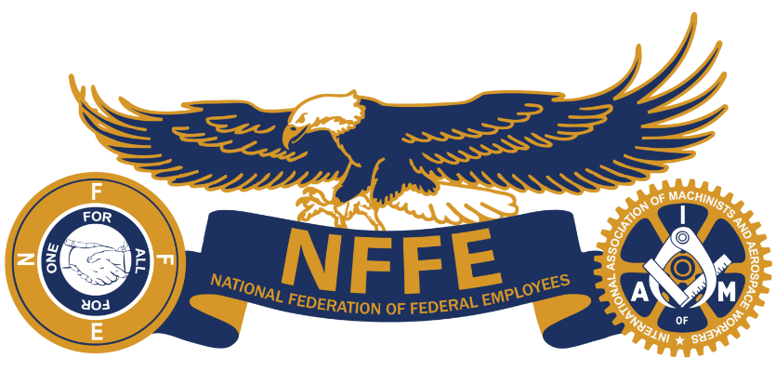
NFFE

News

NFFE Local 1429 Supports their Community by Donating Sports Equipment to Local Elementary School

January 31, 2024

Last week, National Federation of Federal Employees (NFFE) Local 1429 started the new year with a community outreach initiative to give back to their borough of Chambersburg, in Fraklin County, Pennsylvania. Local 1429’s President, Second Vice President, and Recording Secretary attended a parent-teacher organization meeting at Hamilton Heights Elementary School, where they donated brand new equipment for the winter and spring sports seasons.

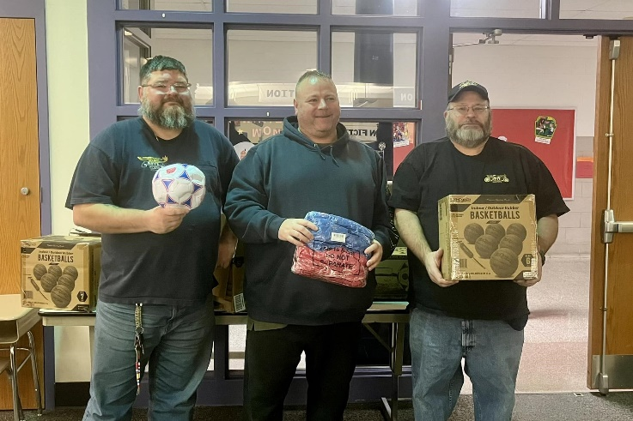
Local 1429 donated 18 soccer balls, a dozen basketballs, three dozen team pinnies, as well as ball bags and cones for the upcoming Hamilton Heights Huskies basketball and soccer seasons. The Hamilton Heights PTO thanked Local 1429 in a Facebook post, saying, “we are grateful and thankful for the donation from National Federation of Federal Employees - NFFE Local 1429.” Local 1429 said, “we not only take care of our union Brothers and Sisters, but we also try to help the future of our country.”

Local 1429 represents Department of Defense workers at Letterkenny Army Depot in Chambersburg, PA. NFFE members at Letterkenny are responsible for repairing and modernizing air and missile defense and precision fires systems to enable multi-domain operations for the U.S. Army Materiel Command.

“I am proud of our members at Letterkenny for the work they do every day to keep our entire country safe, but also for their generosity in the local community,” said NFFE National President Randy Erwin. “Chambersburg is a very tight knit community, and it is great to see that Local 1429 is expanding their presence as a partner and supporter of students and schools in the area. I am looking forward to seeing how NFFE Locals across the country will give back to their communities in 2024. This is a great start!”

www.NFFE.org

